McNamara Pat J (based mainly on CALM News 1986)
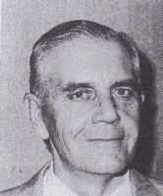
Professional forester, graduated from Oxford, United Kingdom 1950. Joined W.A. Forest Department in 1953. Appointed Assistant Divisional Forests Officer in 1954/55. Worked in Divisions, Working Plans Office and Management Branch in 1950s-60s. Working Plans Officer in Manjimup (c1955) and Perth (1964). District Forests Officer in Pemberton 1959, transferred to Manjimup 1961. Superintendent Northern Region in 1967. Chief of Division in Perth 1979, Deputy Conservator 1975, Assistant Conservator, Operations 1973. Acting Conservator 1983-85. Moved to Timber Bureau 1985 with the formation of CALM. Retired 1986. Died soon afterwards.

